**TRAFFIC MANANGEMENT SYSTEM**

**Hardware Setup:**

You'll need IoT devices like cameras, traffic sensors, and possibly smart traffic lights. These devices should be strategically placed at key locations in your target area.

**Data Collection:**

These devices collect data about traffic flow, vehicle counts, congestion, and weather conditions. This data is sent to a central server or cloud platform via the Internet.

**Data Processing:**

The collected data is processed to extract useful information. This may involve image recognition, data analysis, and machine learning algorithms to identify traffic patterns, congestion points, and anomalies.

**Traffic Analysis**:

Analyze the processed data to make real-time decisions. For example, you can predict traffic jams and suggest alternate routes to drivers through a mobile app or electronic road signs.

**Traffic Control:**

If you have smart traffic lights, they can be controlled based on real-time traffic conditions to optimize traffic flow and reduce congestion.

**User Interface:**

Develop a user-friendly interface (usually a mobile app or website) for users to access traffic information, get route suggestions, and report incidents.

**Alerts and Notifications:**

Implement alerts and notifications for drivers, informing them of accidents, road closures, or severe weather conditions that might affect their routes.

**Remote Monitoring:**

Ensure that traffic authorities can remotely monitor and manage the system, making necessary adjustments as needed.

**Data Storage and Analysis**:

Store historical traffic data for trend analysis, city planning, and optimizing traffic management strategies in the long term.

**Security:**

Implement robust security measures to protect the data and devices from cyber threats.

**Testing and Maintenance**:

Continuously test and maintain the system to ensure its accuracy and reliability.

**Circuit design & program:**

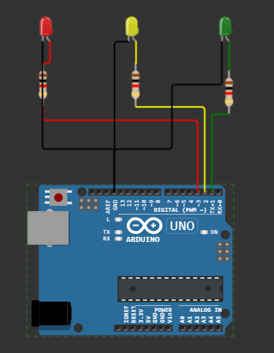

**Program:**

# Define traffic light states

GREEN = 1

YELLOW = 2

RED = 3

# Initialize the traffic light state

current_state = GREEN

while True:

if current_state == GREEN:

print("Green Light - Go")

time.sleep(10) # Green light duration

current_state = YELLOW

elif current_state == YELLOW:

print("Yellow Light - Prepare to Stop")

time.sleep(2) # Yellow light duration

current_state = RED

else:

print("Red Light - Stop")

time.sleep(10) # Red light duration

current_state = GREEN

**Block design for app:**

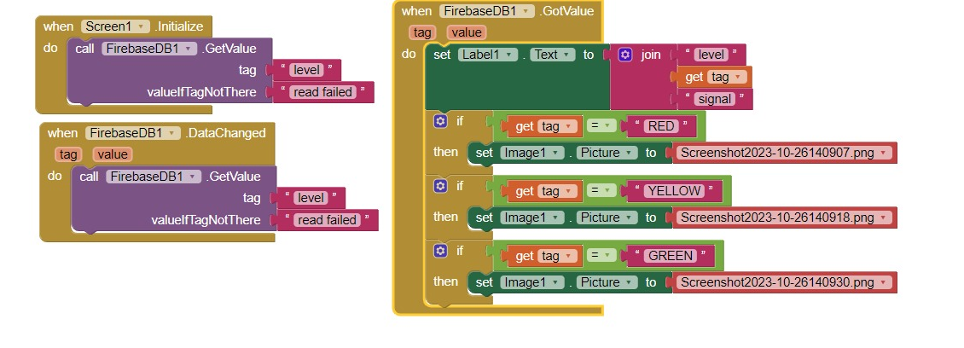**Start a New Project:**

Begin by starting a new project in MIT App Inventor. Give it a meaningful name, such as "TrafficManagerApp."

**Design the User Interface:**

Drag and drop components onto the interface canvas for features like maps, buttons, text labels, and input fields.

Organize and layout the interface for a user-friendly experience.

**Screen Layouts:**

Create different screens (e.g., Home, Maps, Reporting) for various app functions. Use the "Screen Arrangement" component for this.

Define how users will navigate between these screens using buttons or menus.

**Define Components:**

For each screen, add necessary components (e.g., Google Maps, TextBox for user input, Labels for display, etc.).

**Design User Interaction:**

Use event handlers to specify how users will interact with the app components (e.g., what happens when a button is clicked).

**Implement Traffic Data Collection:**

Add components for data collection, like GPS or sensor.

Define how the app will collect and process traffic data, such as real-time traffic information.

**Route Planning Module:**

Create a separate block for route planning using the "Directions" component.

Allow users to input their destination and receive directions.

**User Management:**

Implement user management features, including registration, login, and profile management.

Use "Firebase Authentication" or a similar service for user authentication.

**Reporting and Feedback:**

Add a reporting feature that allows users to report traffic incidents or road conditions

Create a form or input mechanism for users to submit reports.

**Data Storage:**

Use Firebase or a local database component to store user data, traffic information, and reports.

**Security:**

Implement security measures to protect user data and app functionality.

Ensure user authentication for sensitive actions.

**Testing and Debugging:**

Test the app on a physical device or an emulator.

Debug and fix any issues that arise during testing.

**Error Handling:**

Include error handling and notifications for situations where the app encounters problems.

**Integration:**

If needed, integrate external APIs or services for additional data sources, like weather data or traffic APIs.

**User Feedback and Reporting:**

Include mechanisms for users to provide feedback or report issues within the app.

**Documentation:**

Document the app's components, functions, and event handlers for future reference.

**Refinement and Optimization:**

Optimize the app for performance and user experience.

Refine the design based on user feedback.

**Continuous Improvement:**

Plan for future updates and enhancements to the app.